ROLL NO:231501112 NAME:NISHA S

1.SETTING UP THE PYTHON ENVIRONMENT AND LIBRARIES-JUYPTER NOTEBOOK

Create a new notebook for Python

Write and execute Python code

Create new cells for code and Markdown

Demonstrate the application of Jupyter Widgets, Jupyter AI

PROGRAM:

import ipywidgets as widgets

from IPython.display import display

slider = widgets.IntSlider(description='Slider:', min=0, max=100, value=25)

display(slider)

button = widgets.Button(description="Click Me!")

display(button)

def on_button_click(b):

print("Button clicked!")

button.on_click(on_button_click)

OUTPUT:

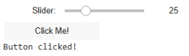

2.EDA-Data Import and Export

Importing data from CSV, Excel, SQL databases, and web scraping Handling different data formats

Export a DataFrame to an Excel file

program:

import numpy as np

import pandas as pd

csv_data = pd.read_csv('/content/data - data.csv')

print(csv_data.head(3))

OUTPUT:

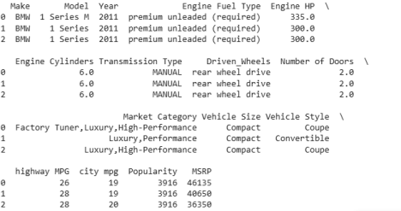

excel_data = pd.read_excel('/content/data.xlsx')

print(excel_data.head(3))

OUTPUT:

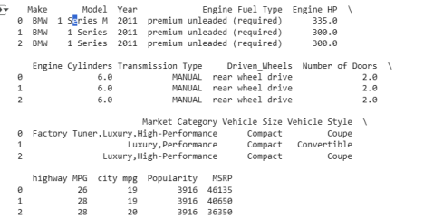

csv_data.to_html('data.htm', index=False)

df_scraped = pd.read_html('data.htm')[0]

print(df_scraped.head())

OUTPUT:

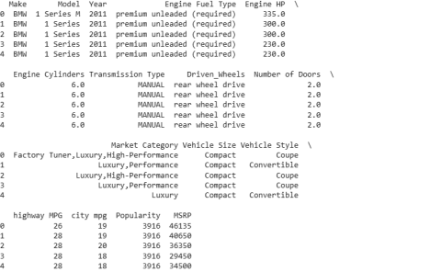

import sqlite3

conn = sqlite3.connect(':memory:')

csv_data.to_sql('data_table', conn, index=False, if_exists='replace') query = "SELECT * FROM data_table LIMIT 5;"

result = pd.read_sql_query(query, conn)

result

OUTPUT:

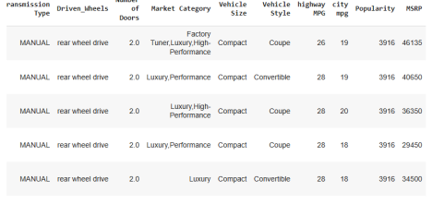

3.EDA-Data Cleaning

Handling missing values detection, filling, and dropping

Removing duplicates and unnecessary

data Data type conversion and ensuring consistency Normalize data (e.g., standardization, min-max scaling).

PROGRAM:

import pandas as pd

df = pd.read_csv('/content/data - data.csv')

print(df.isnull().sum())

print(df.info())

OUTPUT:

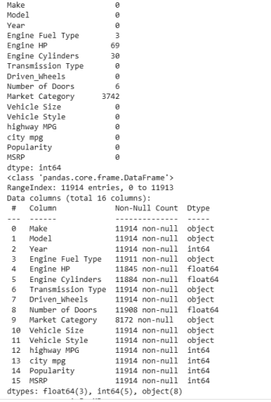

df.columns = df.columns.str.strip()

print(df.columns.tolist())

OUTPUT:

['Make', 'Model', 'Year', 'Engine Fuel Type', 'Engine HP', 'Engine Cylinders', 'Transmission Type', 'Driven_Wheels', 'Number of Doors',

'Market Category', 'Vehicle Size', 'Vehicle Style', 'highway MPG', 'city mpg', 'Popularity', 'MSRP']

df['Engine HP'] = df['Engine HP'].fillna(df['Engine HP'].mean()) df['Engine Cylinders'] = df['Engine Cylinders'].fillna(df['Engine Cylinders'].mean())

df['Number of Doors'] = df['Number of Doors'].fillna(df['Number of Doors'].mean())

df['Engine Fuel Type'] = df['Engine Fuel Type'].fillna(df['Engine Fuel Type'].mode()[0])

df['Market Category'] = df['Market Category'].fillna(df['Market Category'].mode()[0])

df.dropna(inplace=True)

print(df.isnull().sum())

OUTPUT:

Make 0

Model 0

Year 0

Engine Fuel Type 0

Engine HP 0

Engine Cylinders 0

Transmission Type 0

Driven_Wheels 0

Number of Doors 0

Market Category 0

Vehicle Size 0

Vehicle Style 0

highway MPG 0

city mpg 0

Popularity 0

MSRP 0

dtype: int64

df.drop_duplicates(inplace=True)

columns_to_numeric = ['Engine HP', 'Engine Cylinders', 'Number of Doors', 'highway MPG', 'city mpg', 'MSRP']

df[columns_to_numeric] = df[columns_to_numeric].apply(pd.to_numeric, errors='coerce')

df['Engine Fuel Type'] = df['Engine Fuel Type'].str.lower().str.strip() df['Transmission Type'] = df['Transmission Type'].str.upper().str.strip() df['Driven_Wheels'] = df['Driven_Wheels'].str.lower().str.strip() print(df.dtypes)

print(df[['Engine Fuel Type', 'Transmission Type',

'Driven_Wheels']].head())

OUTPUT:

Make object

Model object

Year int64

Engine Fuel Type object

Engine HP float64

Engine Cylinders float64

Transmission Type object

Driven_Wheels object

Number of Doors float64

Market Category object

Vehicle Size object

Vehicle Style object

highway MPG int64

city mpg int64

Popularity int64

MSRP int64

dtype: object

Engine Fuel Type Transmission Type Driven_Wheels 0 premium unleaded (required) MANUAL rear wheel drive 1 premium unleaded (required) MANUAL rear wheel drive 2 premium unleaded (required) MANUAL rear wheel drive 3 premium unleaded (required) MANUAL rear wheel drive 4 premium unleaded (required) MANUAL rear wheel drive

from sklearn.preprocessing import MinMaxScaler, StandardScaler numeric_cols = ['Engine HP', 'Engine Cylinders', 'Number of Doors', 'highway MPG', 'city mpg', 'MSRP']

df[numeric_cols] = df[numeric_cols].apply(pd.to_numeric, errors='coerce') df_clean = df.dropna(subset=numeric_cols)

min_max_scaler = MinMaxScaler()

df_clean[numeric_cols] =

min_max_scaler.fit_transform(df_clean[numeric_cols])

print(df_clean[numeric_cols].head())

OUTPUT:

Engine HP Engine Cylinders Number of Doors highway MPG city mpg \ 0 0.295983 0.375 0.0 0.040936 0.092308 1 0.258985 0.375 0.0 0.046784 0.092308 2 0.258985 0.375 0.0 0.046784 0.100000 3 0.184989 0.375 0.0 0.046784 0.084615 4 0.184989 0.375 0.0 0.046784 0.084615

MSRP

0 0.021384

1 0.018727

2 0.016643

3 0.013300

4 0.015747

4.EDA-Data Inspection and Analysis

Viewing and inspecting DataFrames

Filtering and subsetting data using conditions Descriptive statistics: measures of central tendency (mean, median, mode) and measures of dispersion (range, variance, standard deviation)

PROGRAM:

import pandas as pd

import seaborn as sns

import matplotlib.pyplot as plt

df = pd.read_csv("data - data.csv")

print("First 5 rows:")

print(df.head())

print("\nShape of dataset:", df.shape)

print("\nColumn names:")

print(df.columns)

print("\nInfo about data types and null values:")

print(df.info())

print("\nSummary statistics:")

print(df.describe())

print("\nRows where MSRP > 50000:")

print(df[df['MSRP'] > 50000].head())

print("\nSelect columns: Engine HP and MSRP")

print(df[['Engine HP', 'MSRP']].head())

print("\nDescriptive statistics for 'Engine HP':")

print(f"Mean: {df['Engine HP'].mean():.2f}")

print(f"Median: {df['Engine HP'].median():.2f}")

print(f"Mode: {df['Engine HP'].mode().values}")

print("\nDescriptive statistics for 'MSRP':")

print(f"Range: {df['MSRP'].max() - df['MSRP'].min()}") print(f"Variance: {df['MSRP'].var():.2f}")

print(f"Standard Deviation: {df['MSRP'].std():.2f}")

plt.figure(figsize=(8,4))

sns.histplot(df['Engine HP'].dropna(), kde=True, bins=30) plt.title('Engine HP Distribution')

plt.xlabel('Engine HP')

plt.ylabel('Frequency')

plt.show()

plt.figure(figsize=(8,4))

sns.boxplot(x=df['MSRP'])

plt.title('Boxplot of MSRP')

plt.xlabel('MSRP')

plt.show()

plt.figure(figsize=(12,8))

sns.heatmap(df.corr(numeric_only=True), annot=True, cmap='coolwarm', fmt=".2f")

plt.title('Correlation Heatmap - Car Dataset')

plt.show()

OUTPUT:

First 5 rows:

Make Model Year Engine Fuel Type Engine HP \ 0 BMW 1 Series M 2011 premium unleaded (required) 335.0 1 BMW 1 Series 2011 premium unleaded (required) 300.0 2 BMW 1 Series 2011 premium unleaded (required) 300.0 3 BMW 1 Series 2011 premium unleaded (required) 230.0 4 BMW 1 Series 2011 premium unleaded (required) 230.0

Engine Cylinders Transmission Type Driven_Wheels Number of Doors \

0 6.0 MANUAL rear wheel drive 2.0 1 6.0 MANUAL rear wheel drive 2.0 2 6.0 MANUAL rear wheel drive 2.0 3 6.0 MANUAL rear wheel drive 2.0 4 6.0 MANUAL rear wheel drive 2.0

Market Category Vehicle Size Vehicle Style \ 0 Factory Tuner,Luxury,High-Performance Compact Coupe 1 Luxury,Performance Compact Convertible 2 Luxury,High-Performance Compact Coupe 3 Luxury,Performance Compact Coupe 4 Luxury Compact Convertible

highway MPG city mpg Popularity MSRP

0 26 19 3916 46135

1 28 19 3916 40650

2 28 20 3916 36350

3 28 18 3916 29450

4 28 18 3916 34500

Shape of dataset: (11914, 16)

Column names:

Index(['Make', 'Model', 'Year', 'Engine Fuel Type', 'Engine HP', 'Engine Cylinders', 'Transmission Type', 'Driven_Wheels', 'Number of Doors', 'Market Category', 'Vehicle Size', 'Vehicle Style',

'highway MPG', 'city mpg', 'Popularity', 'MSRP'], dtype='object')

Info about data types and null values:

<class 'pandas.core.frame.DataFrame'>

RangeIndex: 11914 entries, 0 to 11913

Data columns (total 16 columns):

# Column Non-Null Count Dtype

--- ------ -------------- -----

0 Make 11914 non-null object

1 Model 11914 non-null object

2 Year 11914 non-null int64

3 Engine Fuel Type 11911 non-null object

4 Engine HP 11845 non-null float64

5 Engine Cylinders 11884 non-null float64

6 Transmission Type 11914 non-null object

7 Driven_Wheels 11914 non-null object

8 Number of Doors 11908 non-null float64

9 Market Category 8172 non-null object

10 Vehicle Size 11914 non-null object

11 Vehicle Style 11914 non-null object

12 highway MPG 11914 non-null int64

13 city mpg 11914 non-null int64

14 Popularity 11914 non-null int64

15 MSRP 11914 non-null int64

dtypes: float64(3), int64(5), object(8)

memory usage: 1.5+ MB

None

Summary statistics:

Year Engine HP Engine Cylinders Number of Doors \ count 11914.000000 11845.00000 11884.000000 11908.000000 mean 2010.384338 249.38607 5.628829 3.436093 std 7.579740 109.19187 1.780559 0.881315 min 1990.000000 55.00000 0.000000 2.000000 25% 2007.000000 170.00000 4.000000 2.000000 50% 2015.000000 227.00000 6.000000 4.000000 75% 2016.000000 300.00000 6.000000 4.000000 max 2017.000000 1001.00000 16.000000 4.000000

highway MPG city mpg Popularity MSRP count 11914.000000 11914.000000 11914.000000 1.191400e+04 mean 26.637485 19.733255 1554.911197 4.059474e+04 std 8.863001 8.987798 1441.855347 6.010910e+04 min 12.000000 7.000000 2.000000 2.000000e+03 25% 22.000000 16.000000 549.000000 2.100000e+04 50% 26.000000 18.000000 1385.000000 2.999500e+04 75% 30.000000 22.000000 2009.000000 4.223125e+04 max 354.000000 137.000000 5657.000000 2.065902e+06

Rows where MSRP > 50000:

Make Model Year Engine Fuel Type Engine HP \ 49 BMW 2 Series 2016 premium unleaded (required) 320.0 52 BMW 2 Series 2017 premium unleaded (recommended) 335.0 132 BMW 3 Series 2015 premium unleaded (required) 335.0

294 Ferrari 360 2002 premium unleaded (required) 400.0 295 Ferrari 360 2002 premium unleaded (required) 400.0

Engine Cylinders Transmission Type Driven_Wheels Number of Doors \

49 6.0 AUTOMATIC rear wheel drive 2.0 52 6.0 AUTOMATIC all wheel drive 2.0 132 6.0 AUTOMATIC rear wheel drive 4.0 294 8.0 MANUAL rear wheel drive 2.0 295 8.0 MANUAL rear wheel drive 2.0

Market Category Vehicle Size Vehicle Style \ 49 Factory Tuner,Luxury,High-Performance Compact Convertible 52 Factory Tuner,Luxury,High-Performance Compact Convertible 132 Luxury,High-Performance,Hybrid Midsize Sedan 294 Exotic,High-Performance Compact Convertible 295 Exotic,High-Performance Compact Coupe

highway MPG city mpg Popularity MSRP

49 30 20 3916 50750

52 32 21 3916 51050

132 33 25 3916 50150

294 15 10 2774 160829

295 15 10 2774 140615

Select columns: Engine HP and MSRP

Engine HP MSRP

0 335.0 46135

1 300.0 40650

2 300.0 36350

3 230.0 29450

4 230.0 34500

Descriptive statistics for 'Engine HP':

Mean: 249.39

Median: 227.00

Mode: [200.]

Descriptive statistics for 'MSRP':

Range: 2063902

Variance: 3613104336.03

Standard Deviation: 60109.10

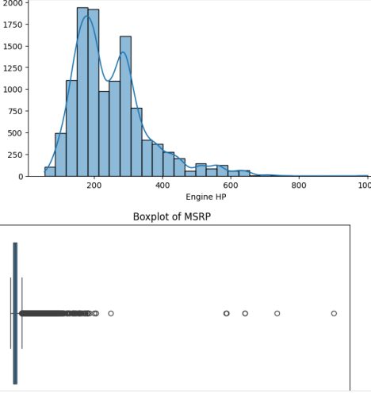

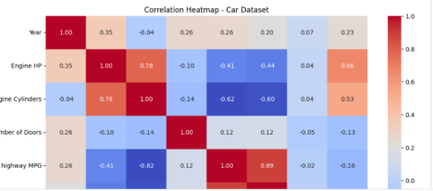

EXP 5-EDA-DataVisualization with Matplotlib Basicplotting: line charts, bar charts, histograms

import matplotlib.pyplot as plt

import numpy as np

# Sample Dataset (Student Scores)

students = ["Alice", "Bob", "Charlie", "David", "Eva"]

math_scores = [85, 78, 92, 74, 88]

science_scores = [80, 82, 89, 70, 90]

english_scores = [78, 85, 84, 76, 86]

# 1. Line Chart (Trend of Math Scores)

plt.figure(figsize=(6,4))

plt.plot(students, math_scores, marker='o', linestyle='--', color='blue', label="Math")

plt.title("Line Chart - Math Scores")

plt.xlabel("Students")

plt.ylabel("Scores")

plt.legend()

plt.grid(True)

plt.show()

# 2. Bar Chart (Comparison of Science Scores)

plt.figure(figsize=(6,4))

plt.bar(students, science_scores, color='orange')

plt.title("Bar Chart - Science Scores")

plt.xlabel("Students")

plt.ylabel("Scores")

plt.show()

# 3. Histogram (Distribution of English Scores)

plt.figure(figsize=(6,4))

plt.hist(english_scores, bins=5, color='green', edgecolor='black')

plt.title("Histogram - English Scores Distribution")

plt.xlabel("Score Range")

plt.ylabel("Frequency")

plt.show()

OUTPUT:

